# MARY MWANIKI

# ENVIRONMENT SET UP DOCUMENTATION

1. SELECTING YOUR OPERATING SYSTEM

**Windows 11 installation:**

[Download Windows 11](https://www.microsoft.com/software-download/windows11)

STEPS:

* Visit the Windows 11 download page.
* Download the Windows 11 Installation Assistant.
* Run the Installation Assistant and follow the on-screen instructions to install Windows 11.
* Complete the setup and personalize your Windows 11 environment.

1. INSTALLING A TEXT EDITOR OR INTEGRATED DEVELOPMENT ENVIRONMENT (IDE)

**Download and install Visual Studio Code (Vs Code):**

[Download Vs Code](https://code.visualstudio.com/Download)

STEPS:

* Visit the Visual Studio Code download page.
* Download the appropriate installer for Windows Os.
* Run the installer and follow the on-screen instructions to complete the installation.
* Launch VS Code and customize the interface according to your preferences.

1. SETTING UP VERSION CONTROL SYSTEM

**Install Git and configure it on your local machine. Create a GitHub account and initialize a Git repository.**

[**Create an Account on GitHub**](https://github.com)

[**Download Git**](https://git-scm.com/)

STEPS:

* Download and install Git from the link above.
* Open a terminal and configure Git:

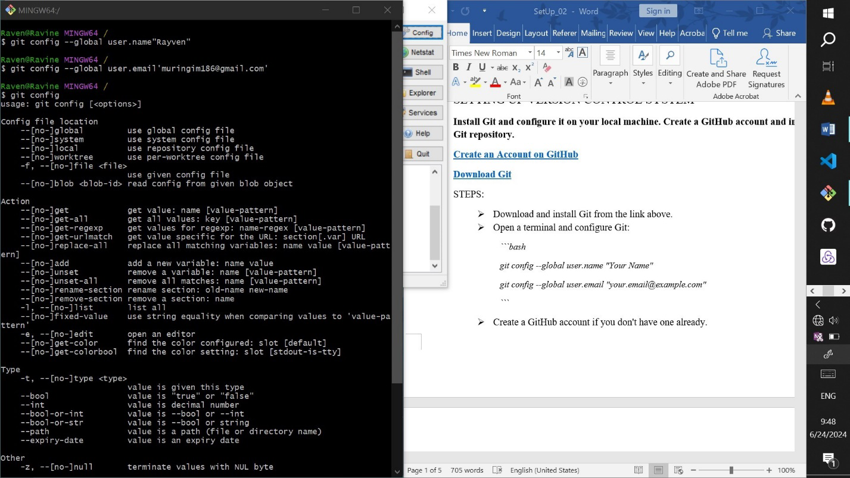

* Create a GitHub account if you don't have one already.
* Create a new repository on GitHub.
* Initialize a local Git repository:

*```bash*

*git init*

*```*

* Add your files and make your first commit:

```bash

git add .

git commit -m "Initial commit"

```

* Link your local repository to GitHub and push your changes:

*```bash*

*git remote add origin https://github.com/yourusername/your-repo.git*

*git push -u origin main*

1. Installing Necessary Programming Languages and Runtimes

**Install Python:**

[**Download Python**](https://www.python.org)

STEPS:

* Visit the Python download page.
* Download the installer for your OS.
* Run the installer and ensure to check the option "*Add Python to PATH*."
* Follow the on-screen instructions to complete the installation.
* Verify the installation:

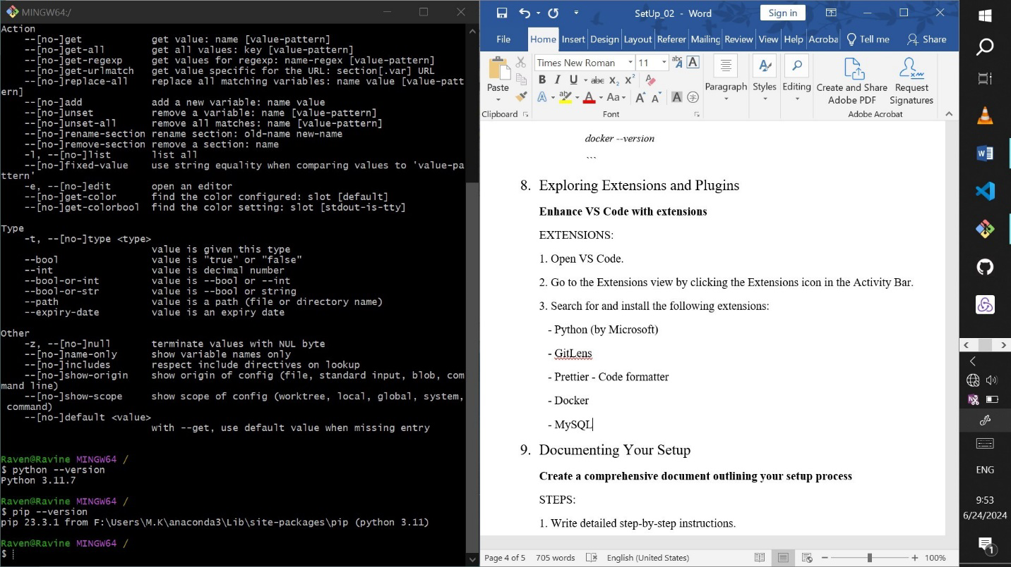

1. Installing Package Managers

**Install pip for Python**

STEPS:

* Pip is included with Python installation. Verify by running:

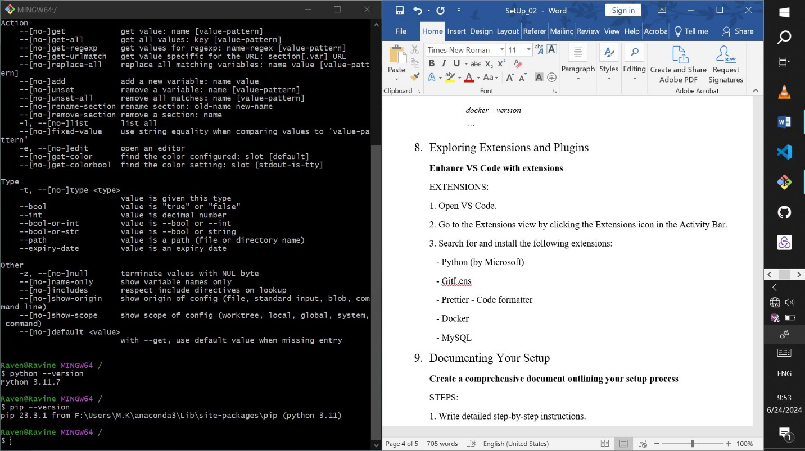

* If not installed, download `get-pip.py` and run it:

*```bash*

*python get-pip.py*

*```*

1. Configuring a Database (MySQL via XAMPP)

**Utilize the MySQL server provided by XAMPP**

[**Download Xampp**](https://www.apachefriends.org/index.html)

STEPS:

1. Download and Install XAMPP (if not already installed):

- Visit the XAMPP download page.

- Download the installer for your OS.

- Run the installer and follow the setup instructions to install XAMPP.

2. Starting MySQL Server with XAMPP:

- Open the XAMPP Control Panel.

- Start the MySQL service by clicking the "Start" button next to "MySQL".

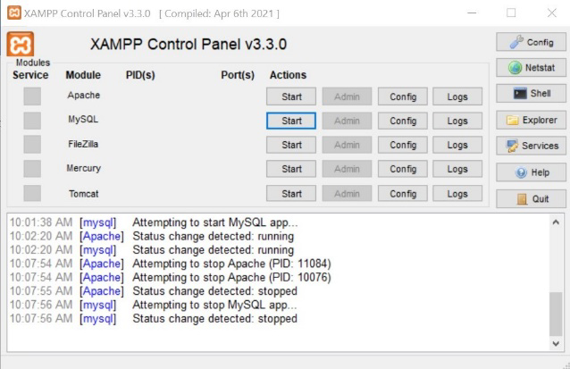 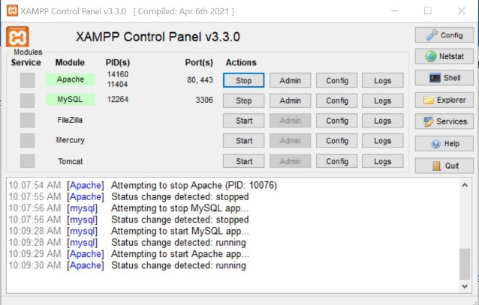

3. Accessing phpMyAdmin:

- Open your web browser and go to `<http://localhost/phpmyadmin>`.

- Use phpMyAdmin to manage your MySQL databases.

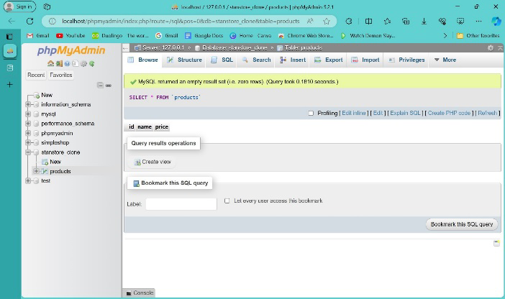

4. Creating a Database:

- In phpMyAdmin, click on the "Databases" tab.

- Enter a name for your new database and click "Create".

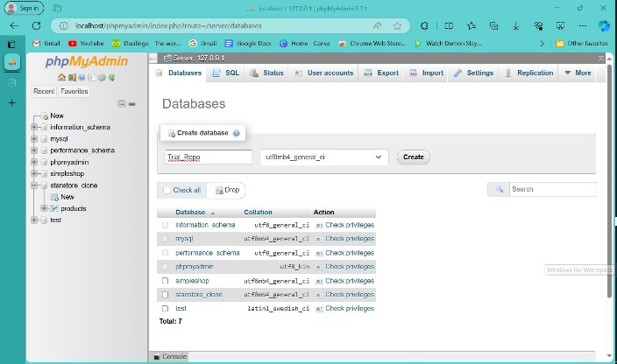 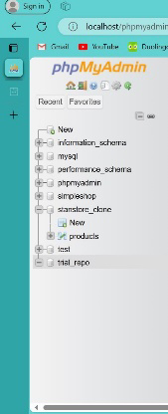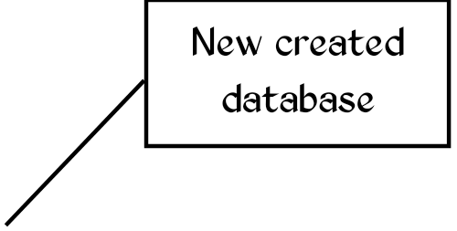

1. Setting Up Development Environments and Virtualization (Optional)

**Install** [**Docker**](https://www.docker.com/get-started)

STEPS:

1. Visit the Docker download page.

2. Download the Docker Desktop installer.

3. Run the installer and follow the on-screen instructions to complete the installation.

4. Verify the installation by running:

*```bash*

*docker --version*

*```*

1. Exploring Extensions and Plugins

**Enhance VS Code with extensions**

EXTENSIONS:

1. Open VS Code.

2. Go to the Extensions view by clicking the Extensions icon in the Activity Bar.

3. Search for and install the following extensions:

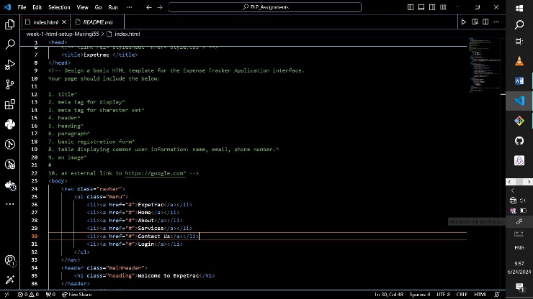 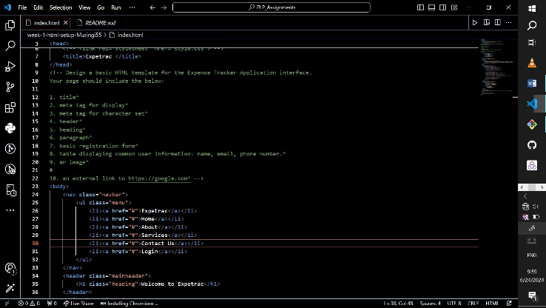 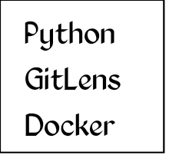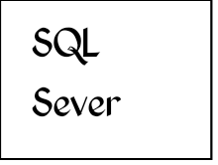

**Sample Project and Reflection**

1. **Create a sample project and reflect on the setup process**

STEPS:

Create a Sample Project:

* Create the project folder and navigate to it.

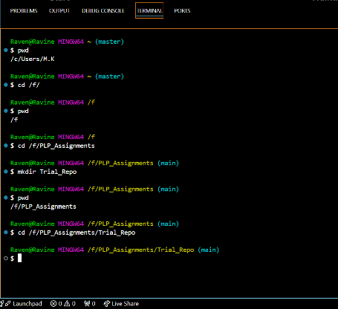

* Initialize a new Git repository in your project folder:

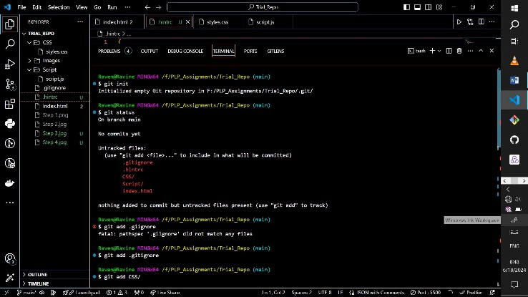

* Create new project files and dependent folders.

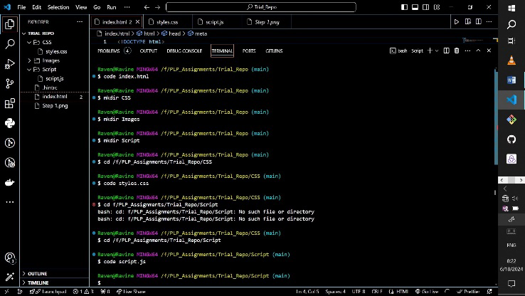

* Add your project files and checking the status:

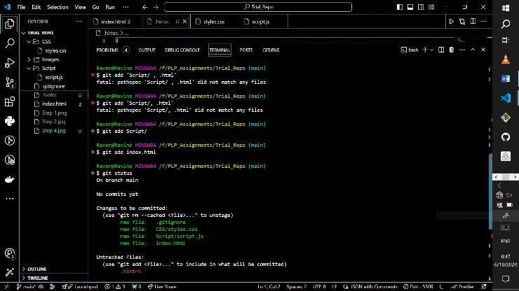

* Commit your changes:

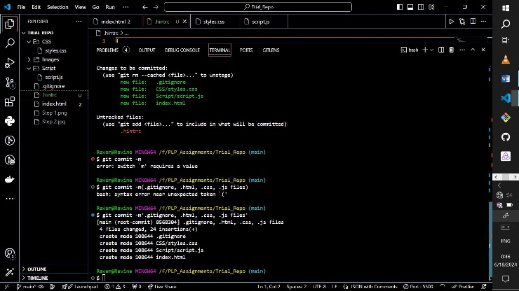

1. **Push Your Local Repository to GitHub**

- Link your local repository to the GitHub repository:

*```bash*

*git remote add origin https://github.com/yourusername/dev-setup-documentation.git*

*```*

- Push your changes to GitHub:

*```bash*

*git push -u origin main*

*```*

**GITHUB REPOSITORY LINKS.**

* [Trial Repo](https://github.com/Muringi55/Trial_Repo.git) - Sample Project
* [Refection.md](https://github.com/Powerlearnproject/se-assignment-1-setting-up-your-developer-environment-Muringi55/blob/main/Reflection.md) - Reflection document